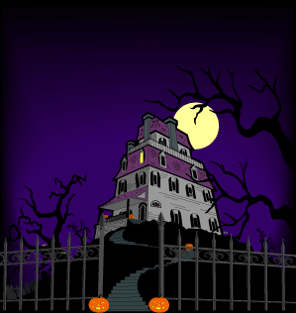

Town Hall Osborne Room, 345 Main Street, Norwell MA
REVISED
7:00 Executive Session – Collective Bargaining

7:30 Call to Order/Pledge of Allegiance

Approval of Agenda

Reports
- Citizen Comments
- Selectmen’s Reports and Announcements
- Town Administrators Report

Discussion/Action Items
- 7:35 Anna D’Entremont - Cultural Council Applicant
- 7:40 Commission on Disabilities – Playground Access and Overview of Commission Activities
- 8:00 Barbara Childs, Barbara Gingras, Rosemary O’Connor - Senior Work Program Update
- Clipper Community Complex Athletic Fee Increase
- Request for Pathwalk Peer Review – con’t

Licenses and Permit

Approval of Minutes

Correspondence

Adjournment

Executive Session – None

